(Approx. 1,226 words)

Rescuing Windows with the Trinity Rescue Kit
By Dick Maybach, Member, Brookdale Computer Users’ Group, NJ
May 2015 issue, BUG Bytes
www.bcug.com
n2nd (at) att.net

I've discussed several approaches to restoring a Windows PC in previous articles. Since these are all available on the BCUG Website, I'll just include their references here. As usual the most important rescue step is preparation (Disaster Recovery and Error Correction in Windows 7 – February, 2012). For several years my favorite recovery tool has been PartedMagic (PartedMagic – April 2012). I also wrote a three-article series on recovering files (File Recovery Strategies – June 2012, File Recovery Using Windows Graphical Tools – July 2012, and File Recovery Using Command-line Tools – August 2012). Finally, I documented an example of recovery (Disaster Recovery: A Case Study – June 2013).

If you want to do everything using Windows, your options are limited. If the system won't boot and you've made the preparations discussed in the 2/12 article, follow the procedures discussed there. If this doesn't work, or if you haven't prepared, you will have to remove your hard disk and install it in a working Windows PC on which you've installed recovery tools as described in the 6/12 and 7/12 articles. Indeed, this may be your only option, since Microsoft has announced that it will approve PCs for Windows 10 on which the safe boot option cannot be disabled, and this may make it impossible to boot live media on such machines.

You will have more flexibility if you can use a rescue system on a live CD-ROM or live memory stick, which will allow you to work directly on the ailing PC without removing its hard disk. First the bad news – every useful rescue system I've found runs on Linux. I don't think this will change as both Microsoft and Apple require a separate license for each computer on which you use their operating systems. There are some DOS-based systems, but I haven't found one that has enough useful tools to make it worthwhile. As a result, if you want to able to rescue a Windows system, you will have to learn enough about Linux to at least find your way around its file system, because when you use a Linux-based rescue disk, it mounts your Windows file system as a Linux one. As a result, you won't see a C: drive for example, instead it's probably something like sda1 (disk a, partition 1), and there may also be an sda2 if the first disk has a second partition. If you have a second disk, it will be sdb, and so on. Now the worse news – many of the tools run from the command line. This means you will have to do some reading before you begin, because you probably won't see a menu of choices; instead you'll have to type the command with some arguments. Your reading will allow you to compose a command that does what you need. The prudent user will practice on an old PC with the tools that appear useful; the bold user prefers “under the gun” learning, but bold users and their files are soon separated.

As I said above, my favorite rescue tool is PartedMagic, but you may prefer an alternative. Regardless of which tool or tools you choose, spend some time exploring, preferably on an old, completely backed-up PC, especially if you're not a Linux user. You will be using powerful software, where a minor mistake can wreak real havoc. In this article we'll take a brief look at the Trinity Rescue Kit, http://www.trinityhome.org/Home/index.php?content=TRINITY_RESCUE_KIT____CPR_FOR_YOUR_COMPUTER&front_id=12&lang=en&locale=en. When first started, you see the screen below, which gives you several boot options. In almost all cases, the default is what you want.

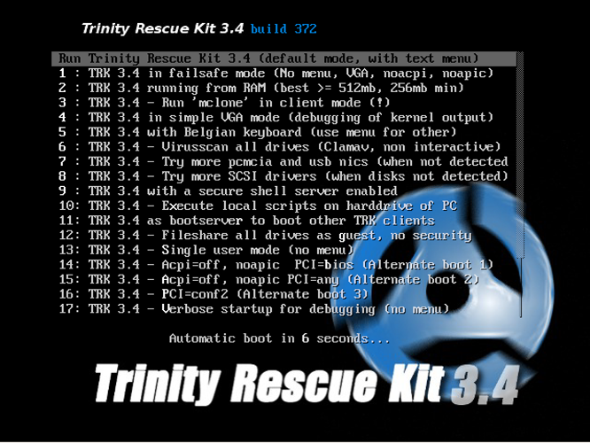

Assuming you use the default boot, you'll see the main menu below.

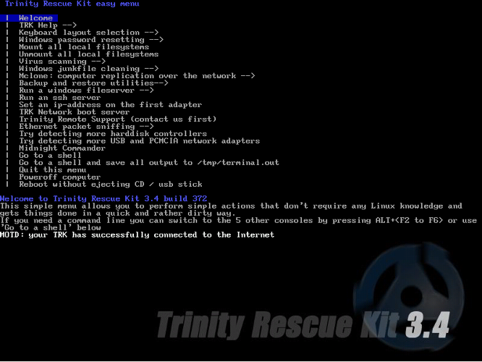

You may recall this sort of menu from your DOS days. You use the cursor keys to select an item then <Enter> to run it. Note the second item, TRK Help, which makes available a detailed manual, the first page of which appears below (assuming you select “Offline web help” when it asks what format you want). Trinity has much better documentation than most other rescue disks, and unlike most others, you don't need Internet access to see it. Although a big disadvantage is that it's not available when you are using the tools. Take good notes as you read the manual.

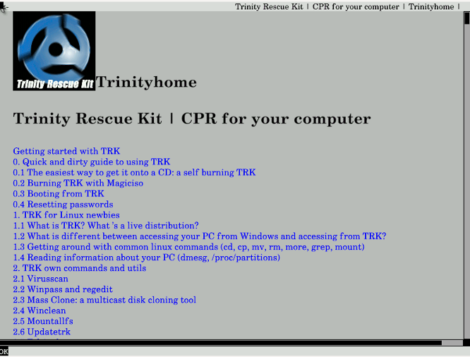

Another important item on the main menu is number 5, Mount all local file systems. When TRK first boots, only the device where it resides (probably a CD-ROM or a memory stick) is mounted. If, for example, you are planning to copy files from your PC to a USB hard drive, you would plug in the USB drive and then select item 5, which would make all the PC's disks as well as the external one available to TRK. The screenshot below shows the Midnight Commander file manager (main menu item 19) display after mounting the local file systems.

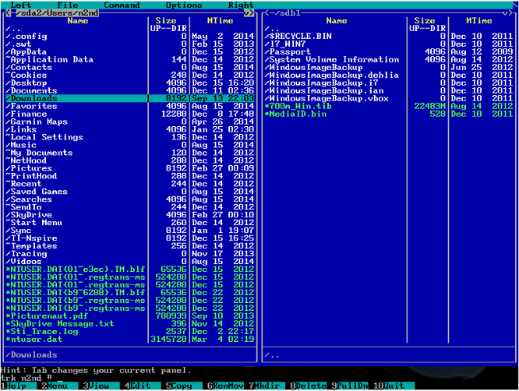

The left side displays my Windows home directory, which in Linux's view resides on partition 2 of drive sda or sda2 instead of C: as Windows would label it. The right side shows partition 1 of sdb, which is a USB hard disk. Midnight Commander is the program you would use to copy your files from a failing Windows disk to an external one.

A unique feature of TRK appears as main menu item 7, Virus scanning, where you can choose from five different scanners. When you select this, you see the top portion of the next screen. The portion below shows the result of activating “Scan with f-prot,” which results in TRK downloading the latest version of that virus scanner and starting it.

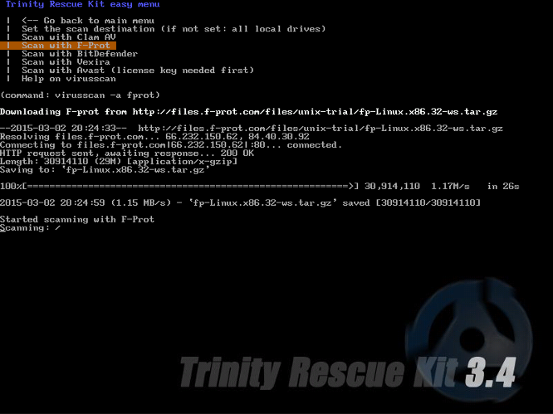

F-prot not only detects viruses, but also removes them. Most Linux systems have only the Clam virus scanner, which only detects and quarantines infected files. If one of the Windows system files is infected, the result will be a virus-free, but broken system.

Another item you might find useful is number 4, Windows password resetting, most likely for a new user who has forgotten his or hers.

Finally, you can go to a shell and use one of the many command-line utilities for more difficult problems. Among the procedures covered in the documentation are
- rescuing files from a dying hard disk,
- recovering deleted files,
- recovering lost partitions,
- bootsector repair,
- cloning a Windows installation,
- hardware testing, and
- PC cleaning.
While the solutions to some common problems appear in the main menu, the Trinity Rescue Kit is capable of a lot more. Even though you must often work in a command-line environment, there is enough good help to make this possible, if perhaps a little uncomfortable, for most inhabitants of the graphic user interface world. It's well worth spending some time with it, just in case disaster strikes. The man command can be a great help here; for example the screen shot below shows the result of typing “man testdisk” on a command line.

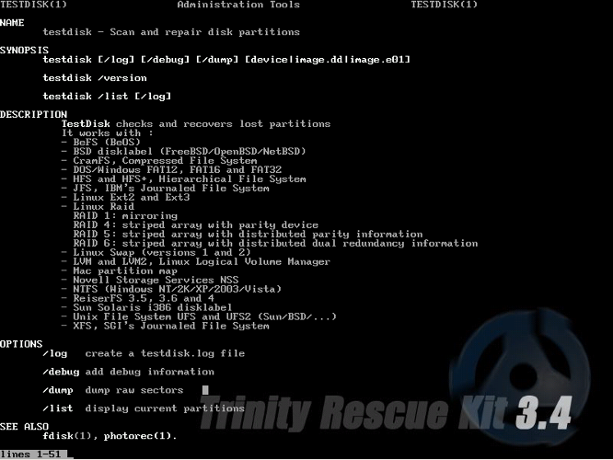

The Trinity Rescue Kit can turn a disaster into an inconvenience, but only if you know how to use it, and this requires that you actually play with it first. If you're reading this, your friends and family probably look to you to solve their PC problems. Becoming familiar with some good repair tools and techniques could be a wise investment.

